

Structural Design

(Inside View)

**Vertical corrugation**

Design#:

33*/*8

1*/*4

33*/*8

 13*/*8 

|  |  |  |  |  |
| --- | --- | --- | --- | --- |
|  |  |  | **140051-04_E** |  |
|  |  |  | Customer: |  |
|  |  |  |  |
|  |  | | **DeMet's Candy** |  |
| 33*/*8 | | |  |
|  |  |  | Description: |  |
|  |  |  |  |

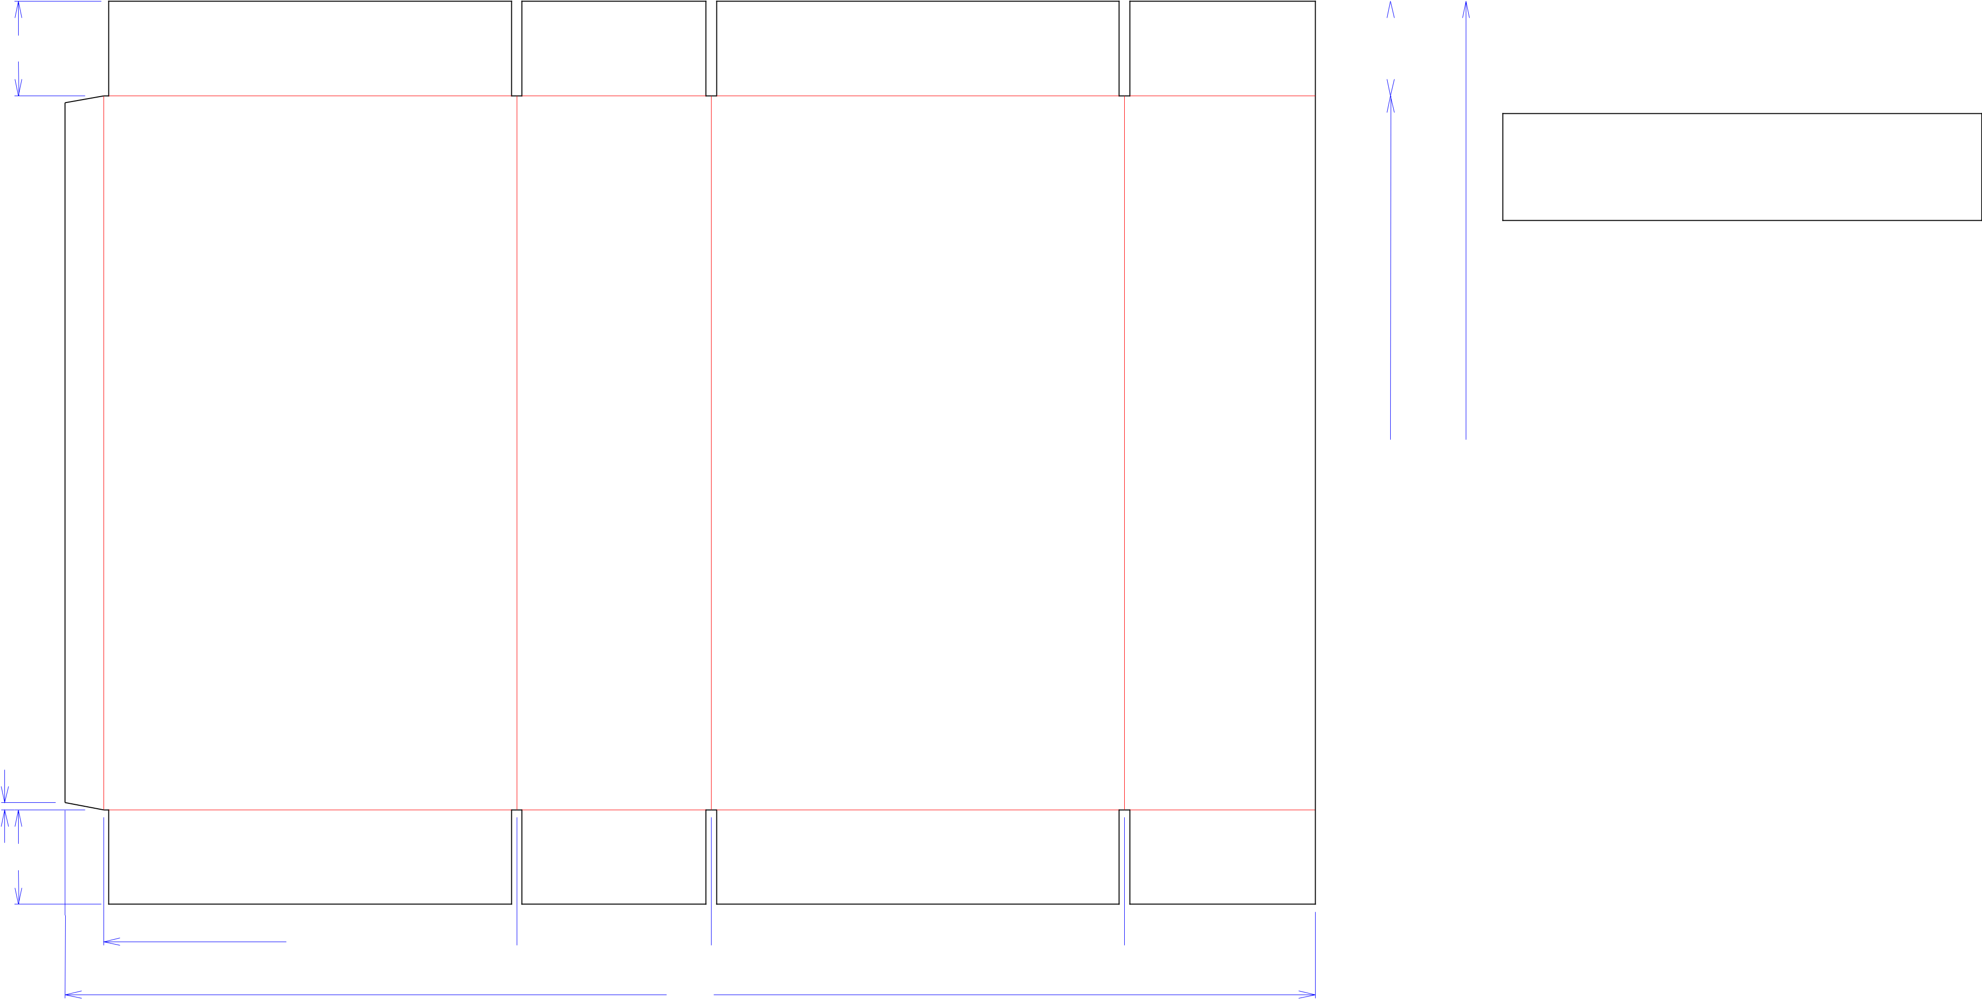

**2015 DG Holiday Power Wing - Shipper**

**SINGLE-OUT DRAWING**

Qty/Unit:

Style: **RSC**

Board: **32BK**

251*/*2 321*/*4 Combination: **35HP - 23M - 35HP**

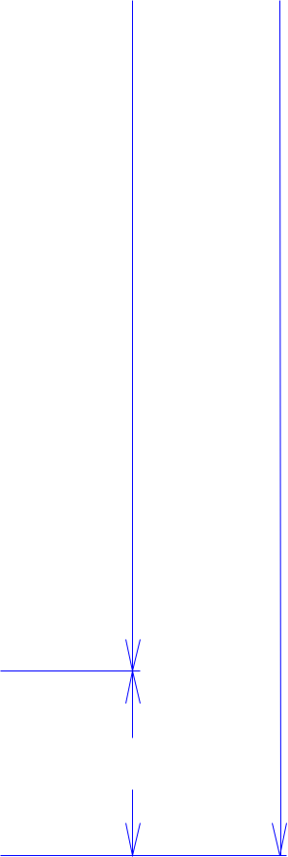

I.D. : **14+5/8 x 6+13/16 x 25+1/4**

Area of Blank - Waste : **9.87 sq. ft.**

Waste on Blank : **1.28%**

Finished Piece Weight: **1.02 lbs./461.47g**

Over-all Blank: **32+1/4 x 44+5/8**

33*/*8 Notes:

143*/*4  615*/*16  143*/*4  613*/*16 

445*/*8

Revision Info: **[E] 01/04/2018**

**glue to L panel (allow. chg AG 1/4/18)**

Designer: **Brian Romankow**

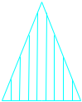

Cut Crease Crease with Matrix Cut Crease Half Knife Cut Tear Tape Perforation



Designright and Copyright of DS Smith Corrugated Packaging Ltd. This technical Specification is subject to Manufacturing tolerances. Drawing dimensions shown are crease to crease. Date printed: 05/03/2019